DEVSU Application

Software Specification:

* Java 11
* Spring Boot 2.7.7
* In Memory H2 Database

# Generate JAR file

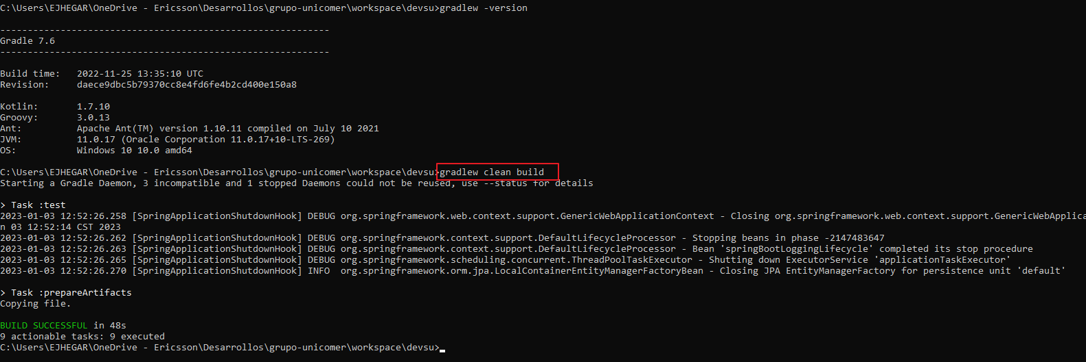

# Test report is generated in

devsu/build/reports/tests/test/index.html

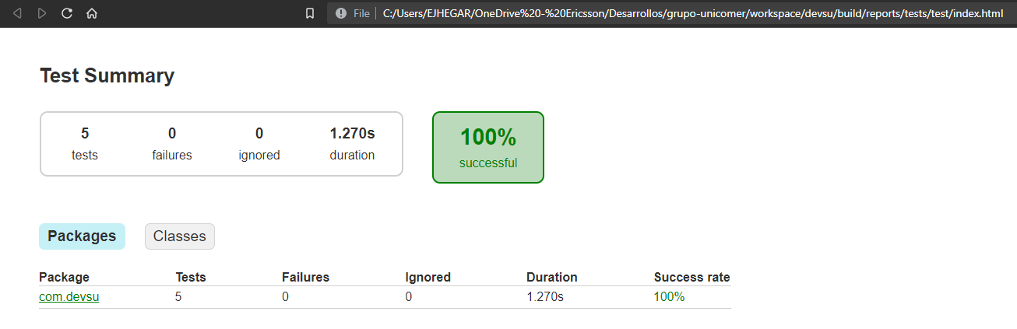

Jar file is located in

devsu/build/Artifact Here, you’ll have the config folder which contains the application.yaml and logback configuration:

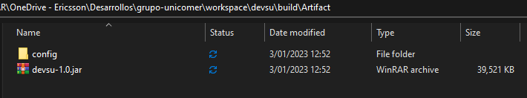

# Execute jar file

java -jar devsu-1.0.jar

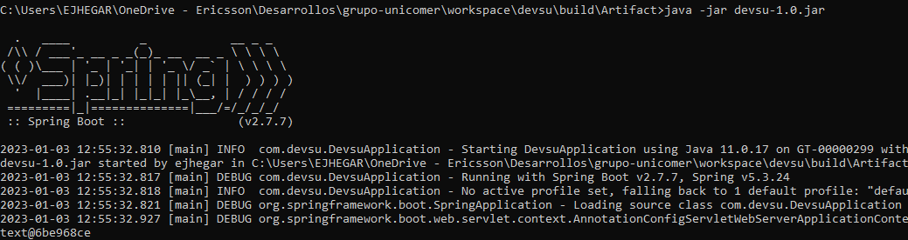

# The Postman collection

is in file Devsu.postman_collection.json

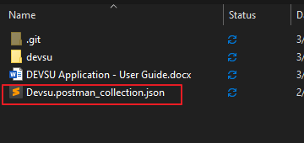

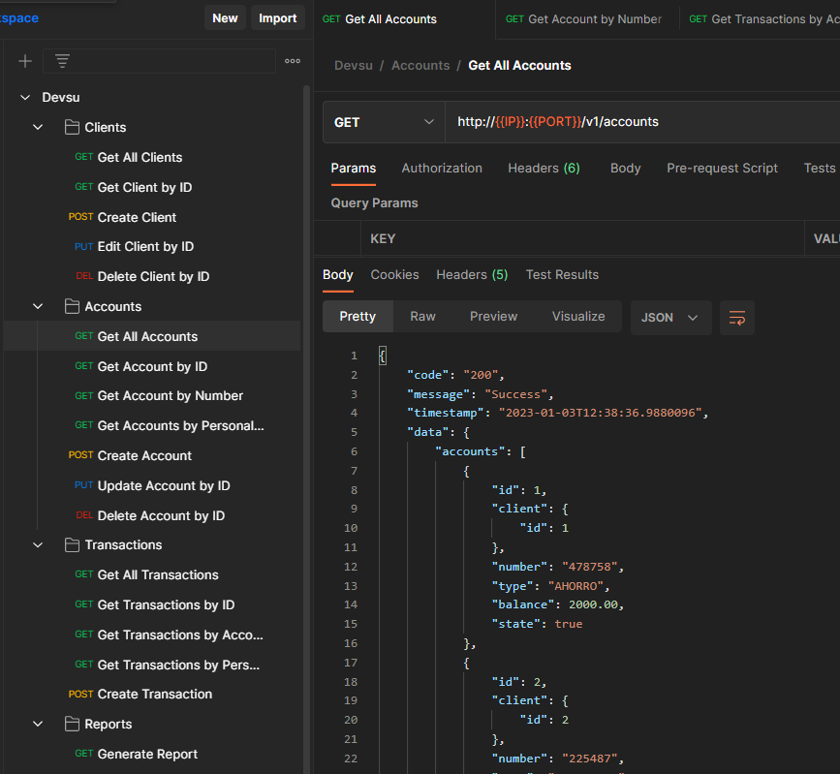

# Environment variables

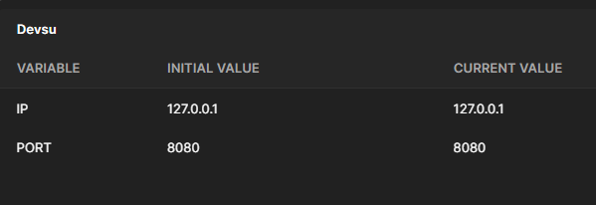

Example:

[GET] http://{{IP}}:{{PORT}}/v1/accounts

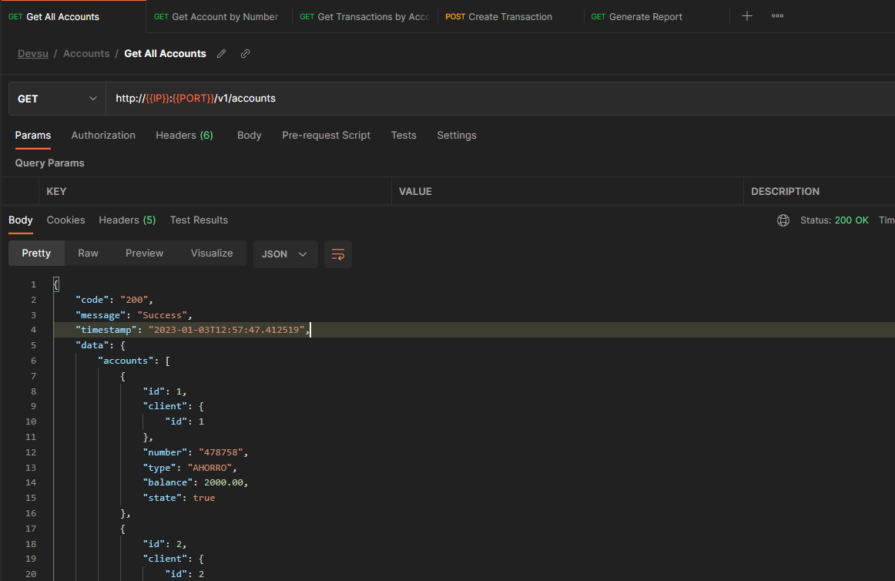

# Database script

file is in devsu\src\main\resources

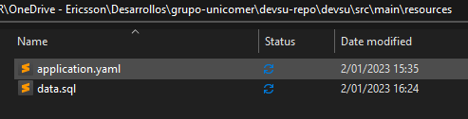

# Logs

Are generated in devsu/build/Artifact/logs

